**VARUN BHARGAVA – 241010282**

**DATA STRUCTURES TASK-2**

**Task 1: Insertion Sort:**

( https://github.com/varunnnb/dsa-sem3-iiitnr/blob/main/lab2/lab2-1.c )

Write a program to perform the following operations using Insertion Sort:

• Take user input to create an array of integers.

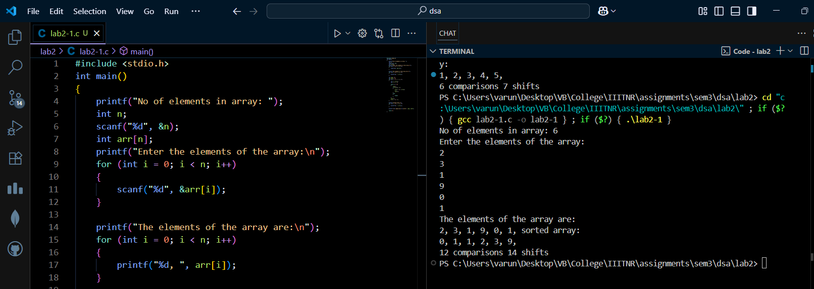

• Sort the array using Insertion Sort in ascending order.

• Display the sorted array.

• Track and display the number of comparisons and shifts performed during the sorting

process.

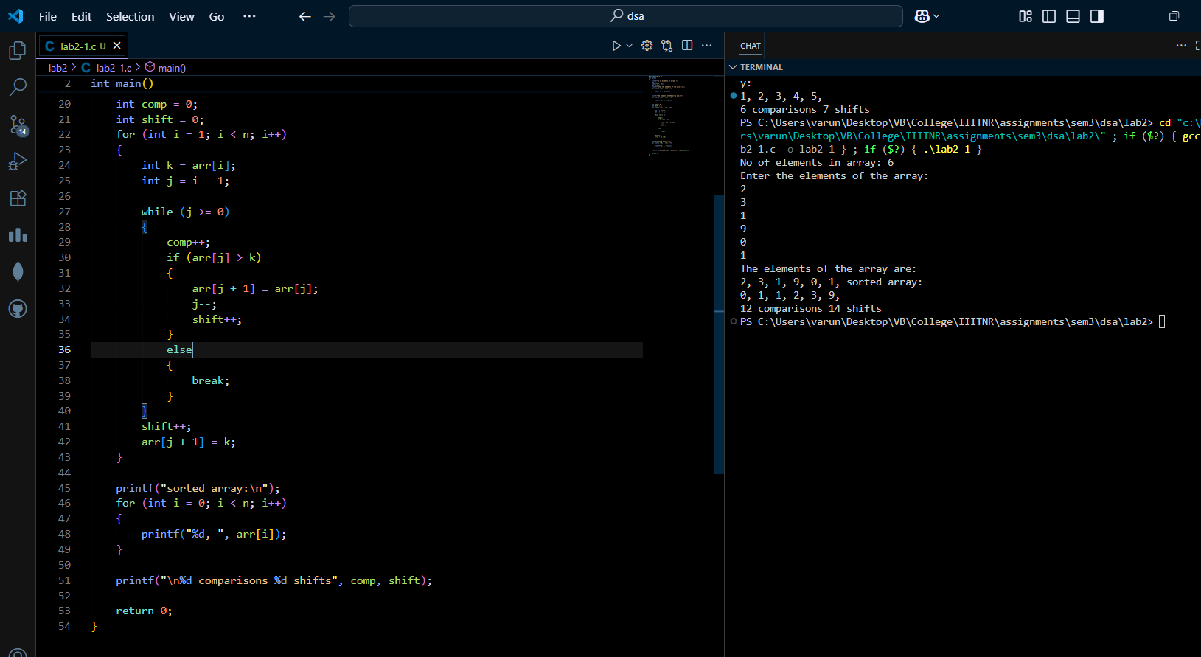

**Task 2: Selection Sort:**

( https://github.com/varunnnb/dsa-sem3-iiitnr/blob/main/lab2/lab2-2.c )

Write a program to perform the following operations using Selection Sort:

• Take user input to create an array of integers.

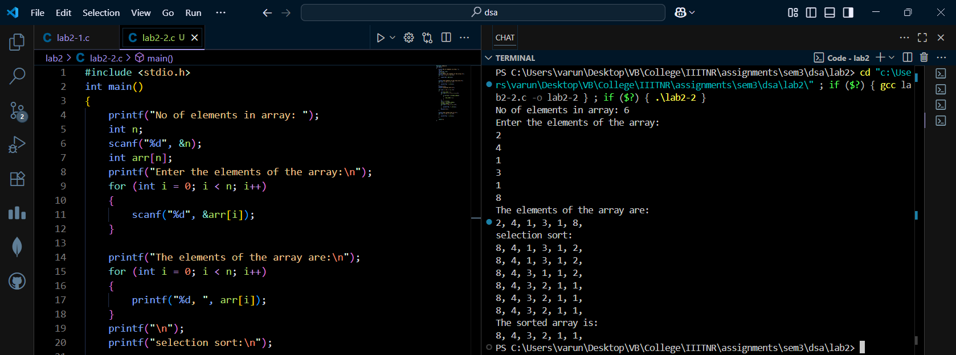

• Sort the array using Selection Sort in descending order.

• Print the array after each pass to show the intermediate steps of sorting.

• Display the final sorted array.

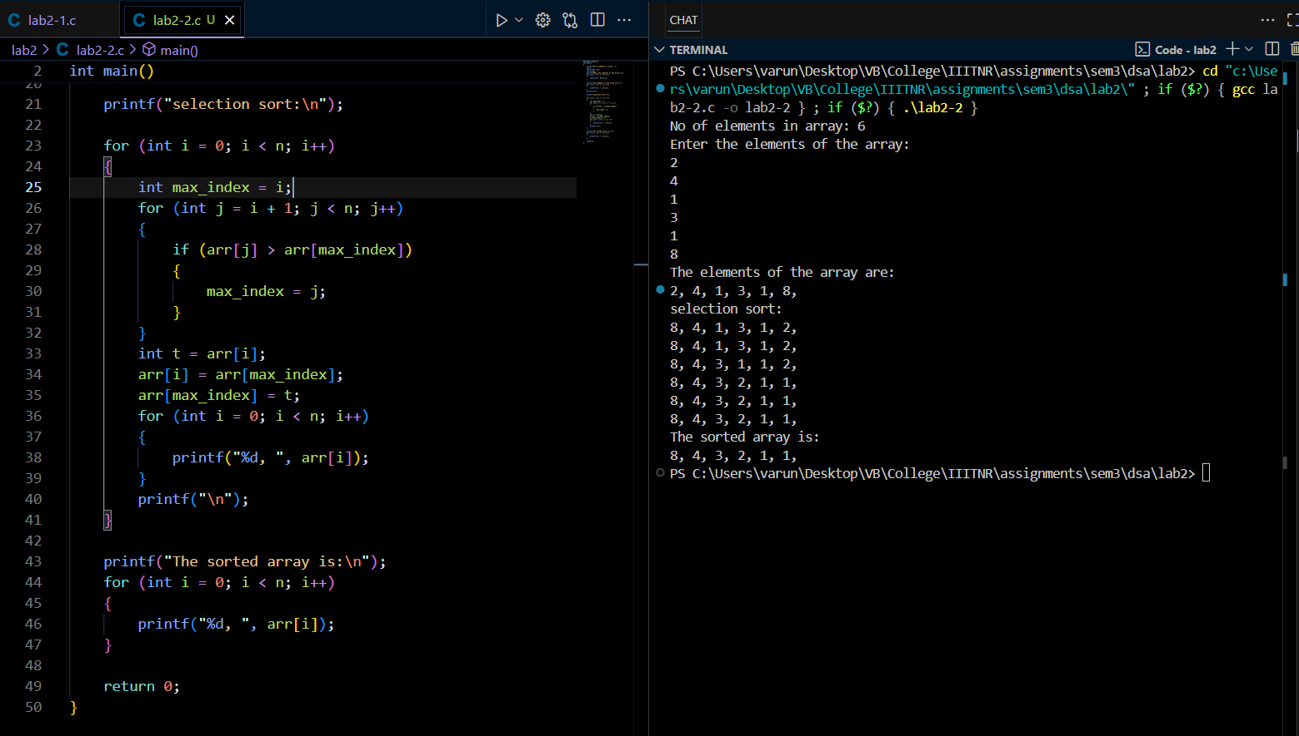

**Task 3: Linear Search:**

( https://github.com/varunnnb/dsa-sem3-iiitnr/blob/main/lab2/lab2-3.c)

Write a program to perform the following operations using Linear Search:

• Take user input to create an array of integers.

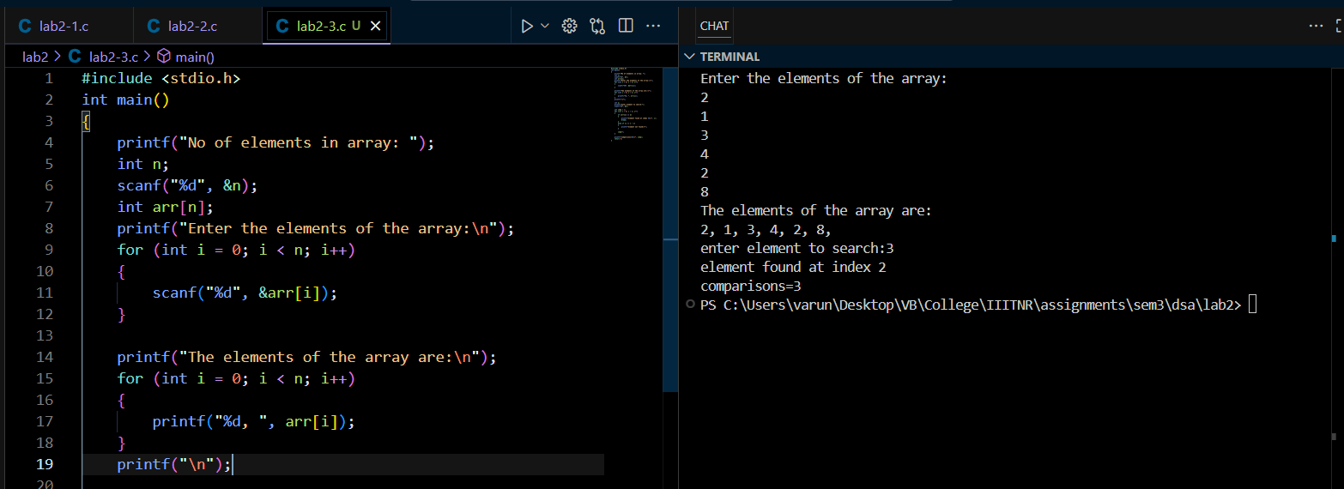

• Take input for the element to be searched in the array.

• Perform Linear Search:

– Display the index of the element if found.

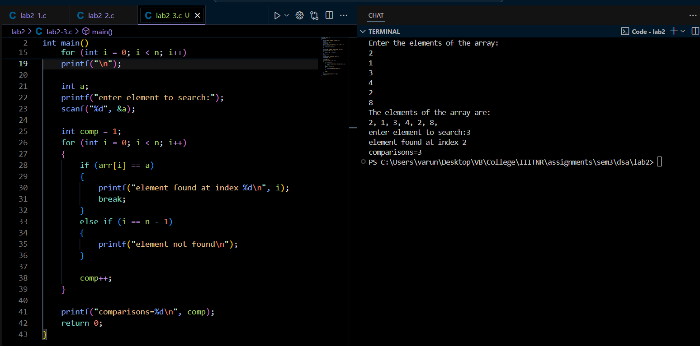

– If not found, display Element not found in the array.

• Display the number of comparisons made during the search.

